Key Stage 5 Geography Curriculum 2024-2025
 | Year 12 |  | Year 13
 | Knowledge and skills | Enrichment | Knowledge and skills | Enrichment
Cycle 1 | Mr: Coastal Systems and Landscapes  - Coasts as natural systems  - Systems and processes  - Sediment cells  - Coastal erosion  - Transportation  - Erosional landforms  - Depositional Landforms  - Sand Dunes and Salt Marshes  - Sea Level Change  - Emergent and Submergent Landforms  - Coastal landscape development  - Coastal management  - ICZM  - Case Studies:  - Holderness  - Sundarbans  - Pevensey Bay  Mrs Sallis:  Hazards  - -The concept of a hazard in a geographical context  - -Plate tectonics  - Hazard management  - Adaptation and mitigation  - -Volcanic hazards  - -Seismic hazards  - -Storm hazards  - -Fires in nature  - Case studies:  - Mt Mayon Philippines (2018)  - Lombok Indonesia Seismic Event (2018)  - Typhoon Haiyan (2013)  - Hurricane Michael (2018)  - Australian Bushfires (2019-20)  - Multi-hazardous event the Philippines  Mr Bell:  Key skills and Exam Technique |  | Mr Bell: Global Systems and Global Governance  - Globalisation  - The flows  - Global Systems  - International Trade  - Trade Blocs  - The coffee trade  - TNCS  - Global supply chains  - Walmart/ASDA  - Impact of TNCs- Nike  - Global Governance  - The UN  - Global Commons  - Antarctica  - The Future of Geography  - The impacts of Globalisation  Mrs Sallis: Non-Examined Assessment (Coursework)  Continue writing up coursework – at least 1 lesson a fortnight  Year 13s to have one 20 marker a week  Revision sessions and exam skills
 | Assessment: End of cycle test |  | Assessment: End of cycle test
Cycle 2 | Mr Bell: Changing Places  -The nature and importance of places  - Relationships, connections, meaning and representation  Mr Bell: Changing Places  - Relationships, connections, meaning and representation – continued  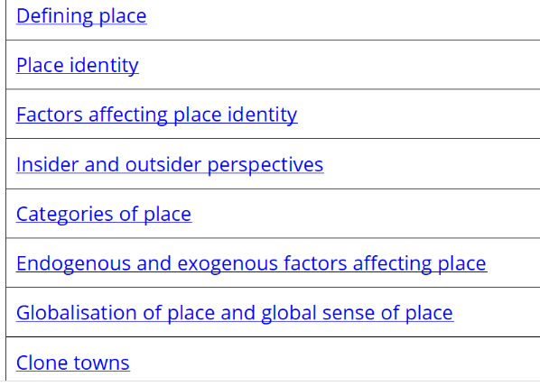  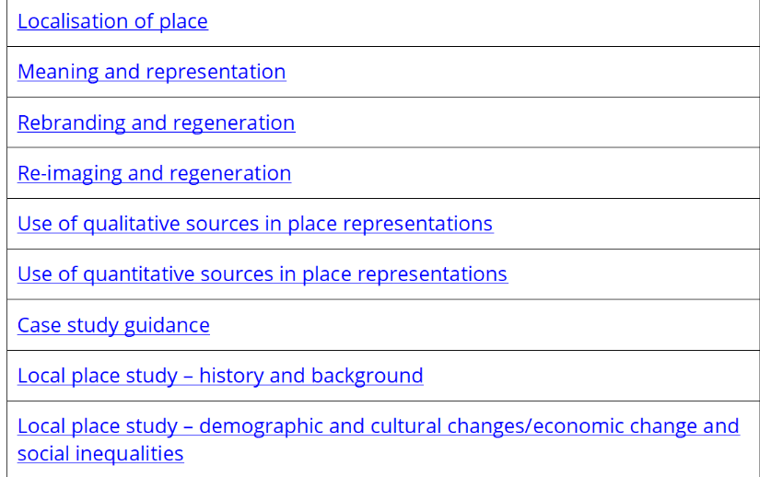  Case Studies:  - Cheltenham  - Dubai  Mrs Sallis:  Population and the Environment  -Environmental context for human population characteristics and change  -Environment and population  -Environment, health and well-being  -Soil-Zonal Soils and Podsols  -Agricultural Systems  -How climate change affects population  -Demographic Transition Model  -Population Pyramids  -Epidemiological transition  -Population Futures  -Malthus and Boserup  -Population ecology  Mr Bell:  Key skills and Exam Technique |  | Mr Bell: Water and Carbon Cycles  - Systems  - The Water Cycle inputs and outputs  - Stores  - Changes  - Global Scale  - Changes over time  - Storm Hydrographs  - Carbon Cycle Inputs and outputs  - Carbon Stores  - Carbon Changes  - Carbon on a global scale  - Carbon Changes over time  - Climate change in detail x2  - Impact of climate change on regional climates  - Feedback loops  - Mitigating CC  - Amazon rainforest case study x2  Mrs Sallis: Non-Examined Assessment (Coursework)  Continue writing up coursework – at least 1 lesson a fortnight  Global Systems and Global Governance
 | Assessment: End of cycle test |  | Assessment: End of cycle test
Cycle 3 | Mr Bell: Water and Carbon Cycles  - Systems  - The Water Cycle inputs and outputs  - Stores  - Changes  - Global Scale  - Changes over time  - Storm Hydrographs  - Carbon Cycle Inputs and outputs  - Carbon Stores  - Carbon Changes  - Carbon on a global scale  - Carbon Changes over time  - Climate change in detail x2  - Impact of climate change on regional climates  - Feedback loops  - Mitigating CC  - Amazon rainforest case study x2  Mrs Sallis:  Population and the Environment  -Principles of population ecology and their application to human populations  -Global population futures  -Case studies:  - Health and wellbeing in Cheltenham (local)  - Health and wellbeing in Japan (far)  - Malaria  - Coronary Heart Disease  NEA  Mr Bell:  Key skills and Exam Technique  Once finished topics: Year 12 Consolidation and Coursework |  | A Level consolidation  -Revision of all topics  -Regular exam skills workshops  -Regular Q&A sessions
 | Assessment: End of cycle test |  | A Level exams

